Attendance Matters
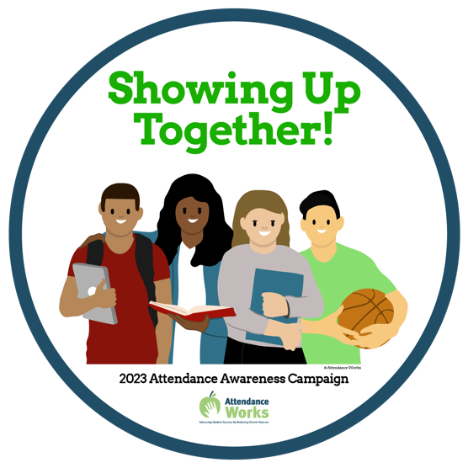

2023-2024
Each day your child is not in school is a missed opportunity to learn something they will need to understand more difficult material later.

Poor attendance can influence whether children read proficiently by the end of third grade.

By 6th grade missing over 10% or 18 days of school a year, is a leading indicator that a student will drop out of high school.

A high school graduate makes a million dollars more than a drop out over a lifetime.

These are a few reasons why attendance matters. Throughout this year our schools will be recognizing our students that work hard to attend and support those students that are struggling.

Thanks to the support of Haverhill Promise and sponsorship of Covanta, Pentucket Bank and Cedars Food there will be giveaways and celebrations at your child’s school. Please join us in talking to your student about how attending now can help them achieve later.

