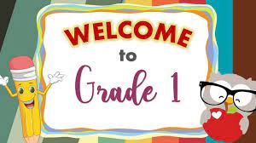

**Supply List**

Hard plastic pencil box

Headphones

Crayons (24 pack)

Glue sticks

Pencils (sharpened)

Scissors (child size)

Pink eraser

Two pocket folder

Spiral bound 1 subject notebook

Binder, 1 inch